COS 226 Algorithms and Data Structures Fall 2009

Final
This test has 12 questions worth a total of 100 points. You have 180 minutes. The exam is closed book, except that you are allowed to use a one page cheatsheet (8.5-by-11, both sides, in your own handwriting). No calculators or other electronic devices are permitted. Give your answers and show your work in the space provided. Write out and sign the Honor Code pledge before turning in the test.
“I pledge my honor that I have not violated the Honor Code during this examination.”
Problem | Score | Problem | Score
0 |  | 6
1 |  | 7
2 |  | 8
3 |  | 9
4 |  | 10
5 |  | 11
Sub 1 |  | Sub 2
Total

Name: Login ID: Precept:
P01 12:30 Anuradha P02 3:30 Berk P03 2:30 Corey
1
0. Miscellaneous. (1 point)
Write your name and Princeton NetID in the space provided on the front of the exam, and circle your precept number.
1. Analysis of algorithms. (15 points)
(a) Which of the following can be performed in linear time in the worst case? Write P (possible), I (impossible), or U (unknown).
−−− Printing the keys in a binary search tree in ascending order. −−− Finding a minimum spanning tree in a weighted graph. −−− Finding all vertices reachable from a given source vertex in a graph. −−− Checking whether a digraph has a directed cycle. −−− Building the Knuth-Morris-Pratt DFA for a given string. −−− Sorting an array of strings, accessing the data solely via calls to charAt(). −−− Sorting an array of strings, accessing the data solely via calls to compareTo(). −−− Finding the closest pair of points among a set of points in the plane, accessing the
data solely via calls to distanceTo().
(b) Match up each operation with the best description of its running time.
−−− Insert into a red-black tree. A. log N worst case
−−− Insert into a 2d-tree. B. log N amortized
−−− Insert into a binary heap. C. log N average case on random inputs
(c) The order-of-growth of the running time of one algorithm is N2; the order-of-growth of the running time of a second algorithm is N3 . List two compelling reasons why a programmer would prefer to use the N3 algorithm instead of the N2 one.
•
•
(d) How many bytes does each Node object consume? Include all memory allocated by a call to new Node(x, y, z). As usual, assume the following values for memory in Java: int (4 bytes), double (8 bytes), reference (4 bytes), object overhead (8 bytes).
public class Node { private Node left, right; private int count; private Point3D point;
public Node(double x, double y, double z) { left = null; right = null; count = 0; point = new Point3D(x, y, z);
} ... }
public class Point3D { private double x, y, z; public Point3D(double x, double y, double z) {
this.x = x; this.y = y; this.z = z;
} ... }
2. Breadth-ﬁrst search. (8 points)
(a) Run breadth-ﬁrst search on the graph below, starting at vertex A. As usual, assume the adjacency sets are in sorted order, e.g., when exploring vertex F , the algorithm considers the edge F -C before F -D, F -E, or F -H.
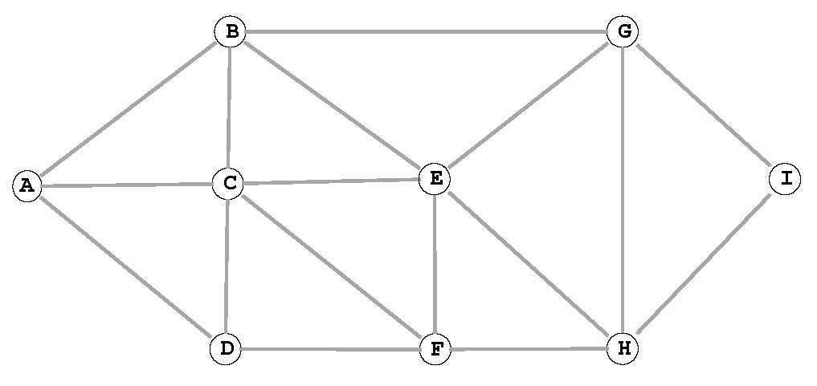
List the vertices in the order in which the vertices are enqueued on the FIFO queue.
A B ___ ___ ___ ___ ___ ___ ___
(b) Consider two vertices x and y that are simultaneously on the FIFO queue at some point during the execution of breadth-ﬁrst search from s in an undirected graph. Which of the following are true?
I. The number of edges on the shortest path between s and x is at most one more than the number of edges on the shortest path between s and y.
II. The number of edges on the shortest path between s and x is at least one less than the number of edges on the shortest path between s and y.
III. There is a path between x and y.
(a) I only. | (d) I, II and III.
(b) I and II only. | (e) None.
(c) I and III only.

3. Minimum spanning tree. (10 points)
For parts (a), (b), and (c), consider the following weighted graph with 9 vertices and 19 edges. Note that the edge weights are distinct integers between 1 and 19.
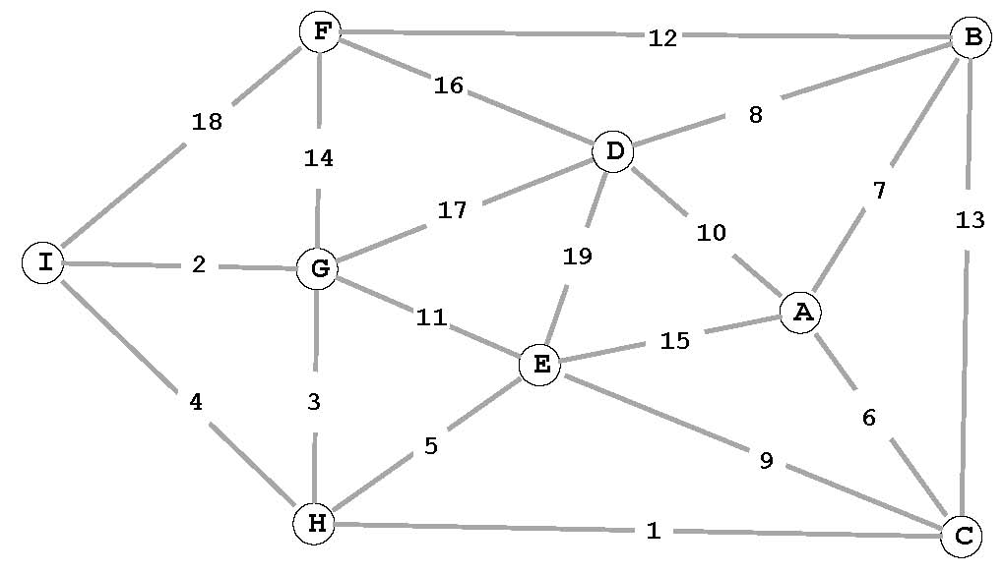
(a) Complete the sequence of edges in the MST in the order that Kruskal’s algorithm includes them.
1 ____ ____ ____ ____ ____ ____ ____
(b) Suppose that the edge D-I of weight w is added to the graph. For which values of w is the edge D-I in a MST?
(c) Complete the sequence of edges in the MST in the order that Prim’s algorithm includes them. Start Prim’s algorithm from vertex A.

The weighted graph from the previous page is repeated here for reference.
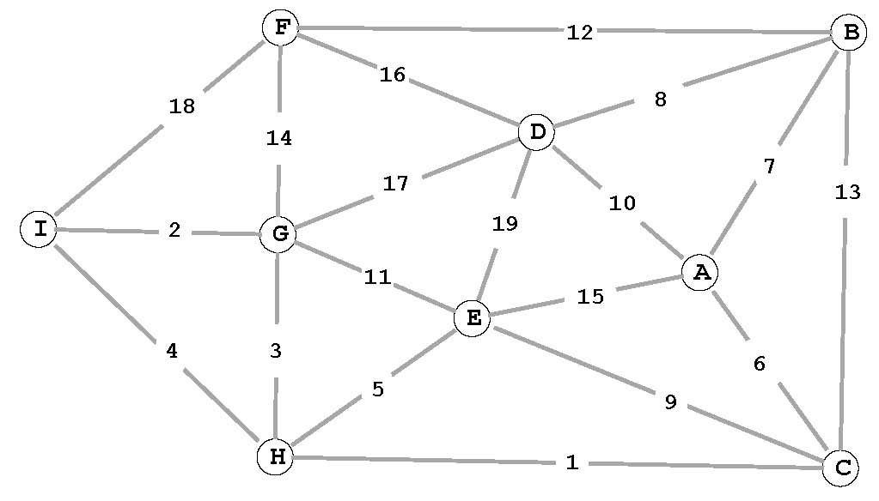
6 ____ ____ ____ ____ ____ ____ ____
(d) Given a minimum spanning tree T of a weighted graph G, describe an O(V ) algorithm for determining whether or not T remains a MST after an edge x-y of weight w is added.
4. Shortest paths. (8 points) Run Dijkstra’s algorithm on the weighted digraph below, starting at vertex A.
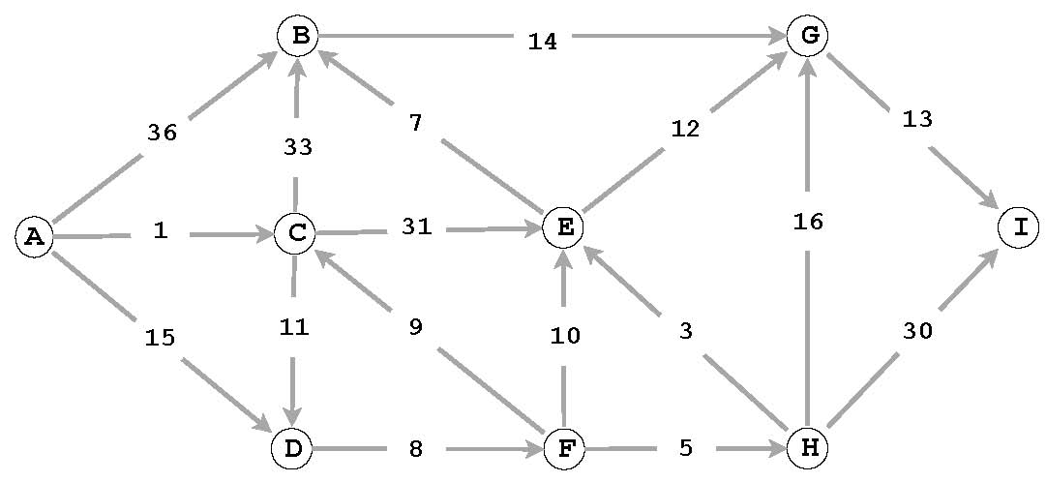
(a) List the vertices in the order in which the vertices are dequeued (for the ﬁrst time) from the priority queue and give the length of the shortest path from A.
vertex: A C ___ ___ ___ ___ ___ ___ ___
distance: 0 1 ___ ___ ___ ___ ___ ___ ___
(b) Draw the edges in the shortest path tree with thick lines in the ﬁgure above.
5. Ternary search tries. (8 points)
Below is the result of inserting a set of strings (and associated integer values) into a ternary search trie.
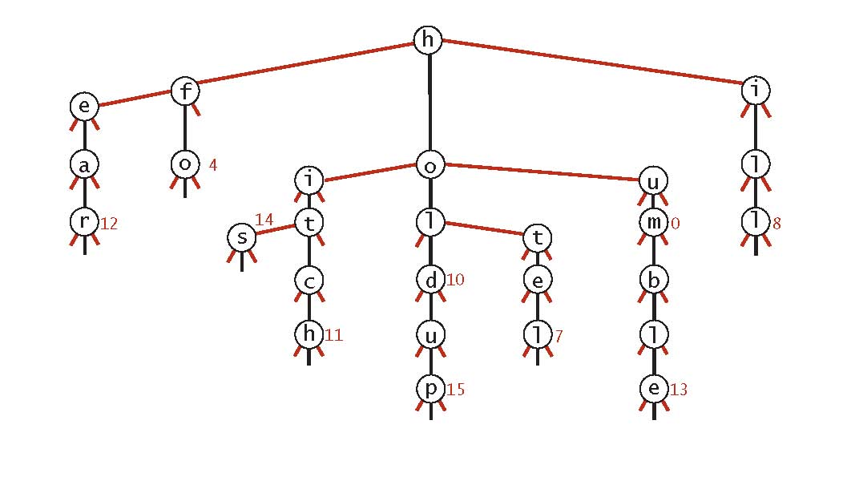
(a) List (in alphabetical order) the set of strings that were inserted.
(b) Add the string hoho (with associated value 77) and then add the string horse (with the associated value 88) to the TST and draw the results in the ﬁgure above.
(c) List two compelling reasons why a programmer would use a TST instead of a red-black tree.

•
•
6. Substring search. (8 points) Create the Knuth-Morris-Pratt DFA for the string aacaaab over the alphabet { a, b, c }
by completing the following table. As usual, state 0 is the start state and state 7 is the accept state.
0 |  |  | 1 |  | 2 |  | 3 |  | 4 |  | 5 |  | 6
a | 1 | 2 |  |  |  | 4 |  | 5 |  | 6
b | 0 | 0 |  |  |  |  |  |  |  |  |  | 7
c | 0 | 0 |  | 3

You may use the following partially-completed graphical representation of the DFA for scratch work (but we will consider your solution to be the completed table above).
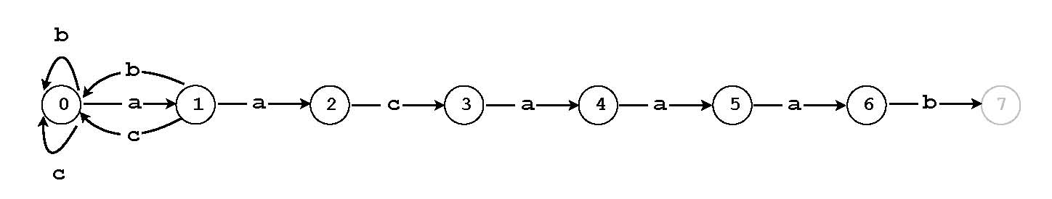
7. Regular expressions. (8 points) Convert the regular expression (a|( b*|cd)*) into an equivalent NFA (nondeter
ministic ﬁnite state automaton) using the algorithm described in lecture by adding E-transition edges to the diagram below.
8. Burrows-Wheeler transform. (8 points)
(a) What is the Burrows-Wheeler transform of
babaabac
(b) What is the Burrows-Wheeler inverse transform of
7 bbbbaaaaa
9. Circular suﬃxes. (6 points)
Consider the following three Java code fragments for forming the circular suﬃxes of a string s of length N.
I. s = s + s; String[] circularSuffixes = new String[N]; for (int i = 0; i < N; i++)
circularSuffixes[i] = s.substring(i, N+i);
II. String[] circularSuffixes = new String[N];
for (int i = 0; i < N; i++) circularSuffixes[i] = s.substring(i, N) + s.substring(0, i);
III. StringBuilder sb = new StringBuilder(); sb.append(s); sb.append(s); String[] circularSuffixes = new String[N]; for (int i = 0; i < N; i++)
circularSuffixes[i] = sb.substring(i, N+i);
Which of the above code fragments consumes space proportional to N?
(a) I only. (d) I, II and III.
(b) I and II only. (e) None.
(c) I and III only.

10. Tandem repeats. (10 points) A tandem repeat of a base string b within a string s is a substring of s consisting of at least
one consecutive copy of the base string b. Given b and s, design an algorithm to ﬁnd a tandem repeat of b within s of maximum length.
For example, if s is "abcabcababcaba" and b is "abcab", then "abcababcab" is the tandem substring of maximum length (2 copies).
Your answer will be graded on correctness, eﬃciency, clarity, and succinctness. Let M denote the length of b and let N denote the length of s. For full credit, your algorithm should take time proportional to M + N.
(a) Describe your algorithm in the space below.
(b) What is the worst-case running time of your algorithm as a function of M and N? Circle the best answer.

NMM + N MN N2 M2 other −−−−−
11. Reductions. (10 points) Consider the following two problems:
- 3Sum. Given N integers x1,x2,...,xN , are there three distinct indices i, j, and k such that xi + xj + xk = 0?
- 4Sum. Given N integers x1,x2,...,xN , are there four distinct indices i, j, k, and l such that xi + xj + xk + xl = 0?

(a) Show that 3Sum linear-time reduces to 4Sum. To demonstrate your reduction, give the 4Sum instance that you would construct to solve the following 3Sum instance: x1,x2,...,xN .
(b) Suppose that Alice discovers an N1.9 algorithm for 3Sum and Bob discovers an N1.9 lower bound for 4Sum. Which of the following can you infer from the fact that 3Sum linear-time reduces to 4Sum?

I. There does not exist an N1.8 algorithm for 3Sum.
II. 3sum and 4sum have the same asymptotic complexity.
III. There exists an N1.9 algorithm for 4Sum.
(a) I only. (d) I, II and III.
(b) I and II only. (e) None.
(c) I and III only.

14

